Client Handbook

Group M

Table of Contents

Introduction 3

User Guide 3

Drawing Application 3

System Requirements 3

Installation & Setup 3

Using The Application 4

Admin Portal 7

System Requirements 7

Installation & Setup 7

Using The Application 9

Security 18

Maintenance & Updates 18

Support & Contact Information 18

Developer Guide 18

Repository 18

Hosting 19

Configuring Backblaze 19

Instructions 19

# Introduction

This user manual provides some general guidance for the users of the Android drawing application and the admin portal application.

Additionally, the manual includes a developer section where information about hosting and other aspects of the project can be found.

# User Guide

## Drawing Application

The Android drawing application provides a simple interface for creating digital drawings.

### System Requirements

To use the admin portal application, you will require:

* An Android tablet device
* An internet connection

### Installation & Setup

Before you can use the drawing application, you need to install it. You can get a copy of the installer by asking your developer to retrieve it from the GitHub repository.

*Note: The installer will be named “MA Drawing App.apk”.*

##### Step-by-step Installation Instructions

1. Open the installer.
2. Once open, a dialog will appear. Press “Install” *(see Figure 1)*

*  
Figure 1 – Android drawing application installation starting dialog*

1. All Done! You will be shown the finishing dialog, from there you can either press “Done” to close the installer or press “Open” to run the app right away. *(see Figure 2)*

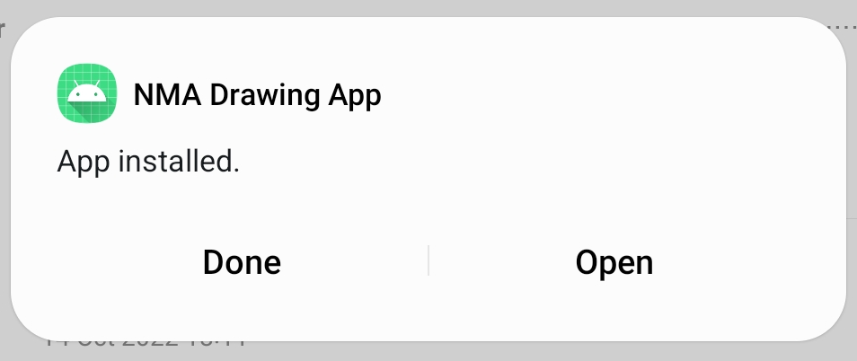

*Figure 2 – Android drawing application installation finishing dialog*

### Using The Application

The starting screen of the Android drawing application provides the option to start a new drawing session or upload drawings that are saved on the device. *(see Figure 3)*

*Figure 3 – Android drawing application starting screen*

#### Setting Up An Event

To set up a drawing session the event moderator must first create an event on the admin portal, enter the event ID in the provided input and press the “Start” button. *(see Figure 4)*

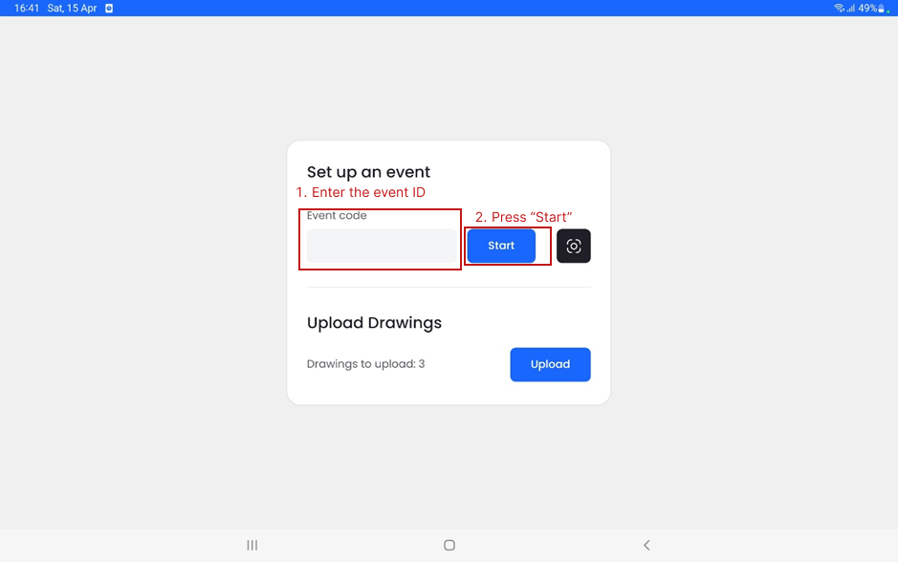

*Figure 4 – Android drawing application starting screen with highlighted inputs*

Once the “Start” button is pressed you will be taken to the drawing screen where the tablet can now be used for drawing. *(see Figure 5)*

#### Drawing View

*Figure 5 – Android drawing application drawing screen*

#### Saving A Drawing

Each person that draws a picture can save their drawing by pressing the “Save Your Drawing” button. Pressing it will prompt the drawer to enter their first name and age. *(see Figure 6)*

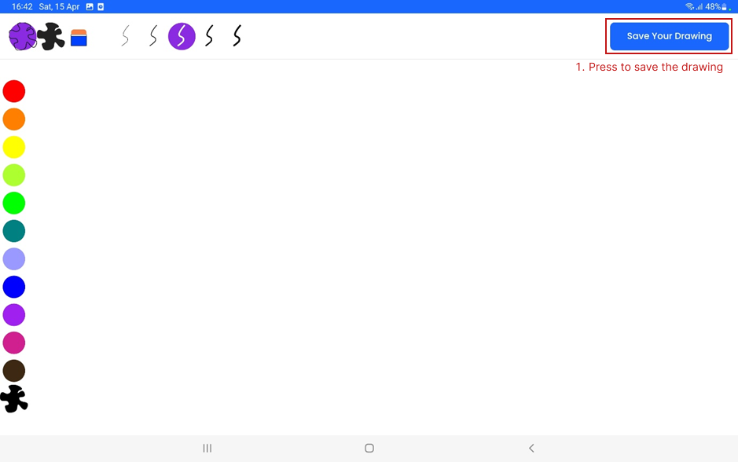

*Figure 6 – Android drawing application drawing screen with highlighted “Save Your Drawing” button*

Upon pressing the button, a dialog will appear prompting you to enter your name and age. *(see Figure 7)*

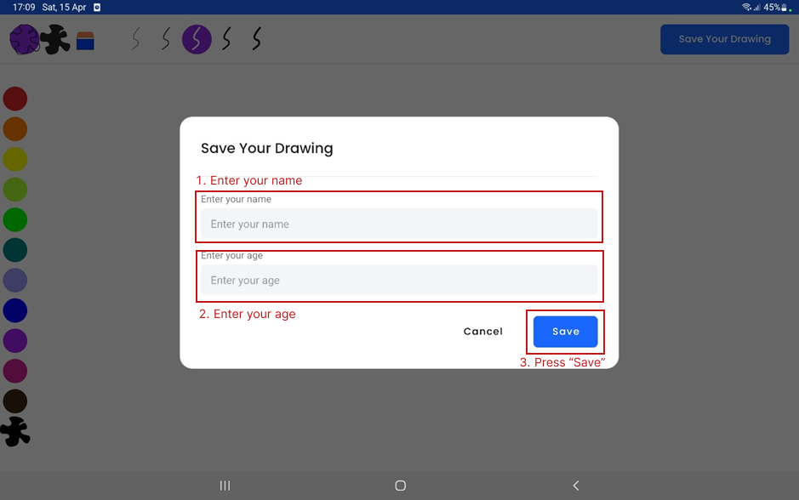

*Figure 7 – Android drawing application save drawing dialog*

Once you have entered your name and age, press the “Save” button. Upon saving the dialog will be dismissed and the canvas will be cleared for the next drawing.

#### Uploading Drawings

At any time after the event — provided an internet connection is available — you can go on the tablet and upload the drawings drawn by participants by navigating to the drawing upload screen, selecting which drawings they want to upload and pressing the “Upload” button. *(see Figure 8)*

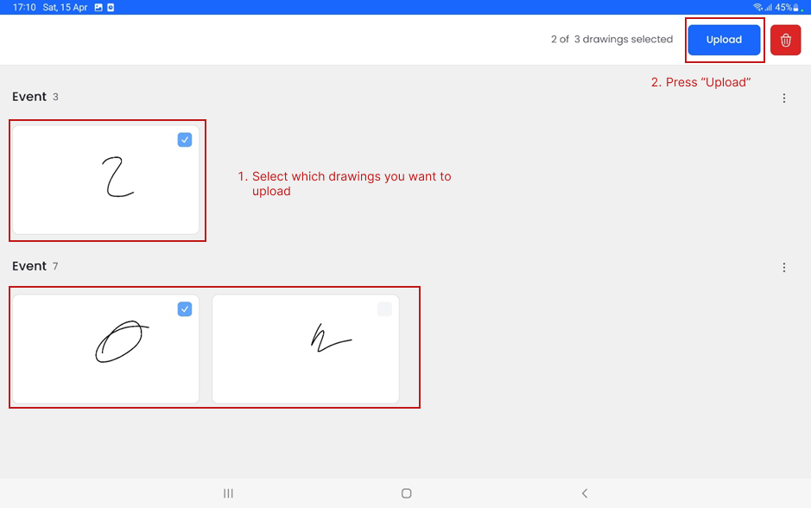

*Figure 8 – Android drawing application drawing upload screen*

## Admin Portal

The admin portal is the application where you can manage all of the data that is relevant to this project as well as score drawings.

### System Requirements

To use the admin portal application, you will require:

* A laptop or desktop device running macOS, Linux or Windows operating system. *(The application is not supported on mobile devices)*
* An internet connection

### Installation & Setup

Before you can use the admin portal, you need to install the application on your device. You can get a copy of the installer by asking your developer to retrieve it from the GitHub repository.

*Note: The installer will be named “MA Admin Portal Installer x.x.x” where the “x.x.x” is the current version number of the application.*

##### Step-by-step Installation Instructions

1. Open the installer.
2. Once open, you will be presented with the option to change the installation directory. If you wish to change it, do so, else continue by pressing “Install” *(see Figure 9)*

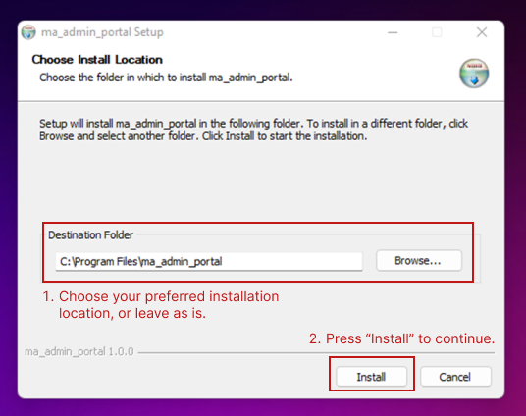

*Figure 9 – Initial installation screen*

1. After a short installation, you will be presented with the option to close the installation. *(see Figure 10)*

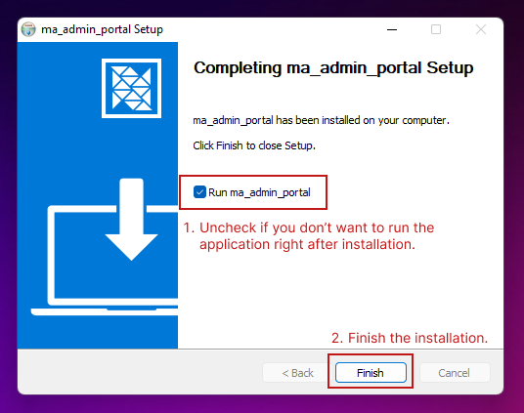

*Figure 10 – Installation finish screen*

If you want to run the application right away keep the “Run ma_admin_portal” checkbox checked, otherwise, uncheck it. Finally, press “Finish” to close the installer.

1. All done! You can now use the admin portal application.

### Using The Application

#### User Selection & Management

Once the application is opened you will be prompted to select the user which will be recorded when scoring drawings. *(see Figure 11)*

*Figure 11 – Admin portal user selection view*

##### Adding A New User

Initially, there will not be any users created, so you will have to do it by pressing the “Add User” button. *(see Figure 12)*

*Figure 12 – Admin portal user selection screen with “Add User” button highlighted*

##### Updating & Deleting A User

Each user in the list can be updated and or deleted by clicking on the vertical ellipsis icon. *(see Figure 13)*

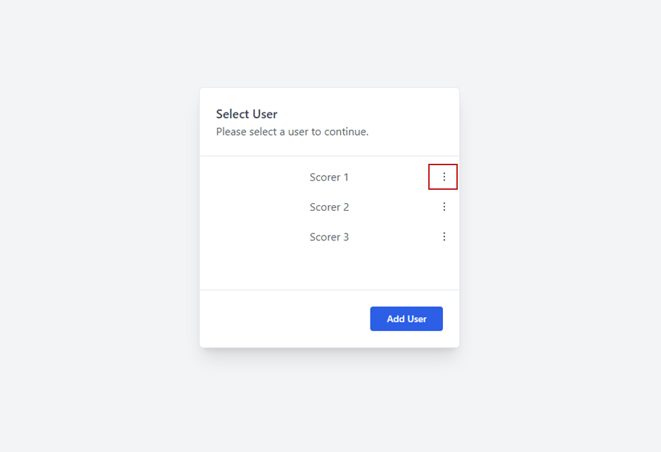

*Figure 13 – Admin portal user selection screen with “Scorer 1” options button highlighted*

After pressing the button, the options page will appear. *(see Figure 14)*

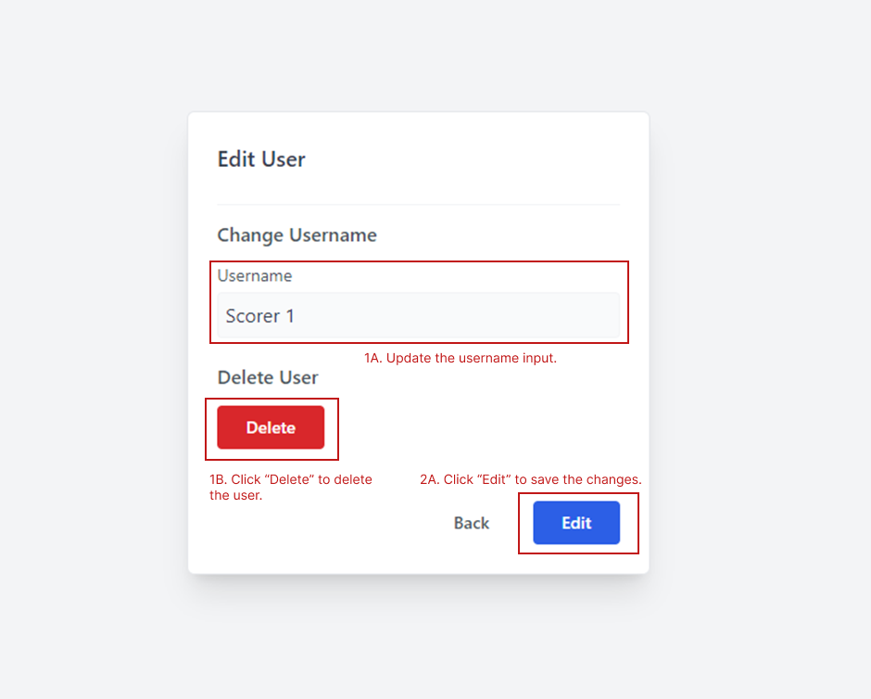

*Figure 14 – User options view*

To change the username, update the username input field and press “Edit” to save the changes.

To delete the user, simply press the “Delete” button and then “Confirm” in the popup dialog. *(see Figure 15)*

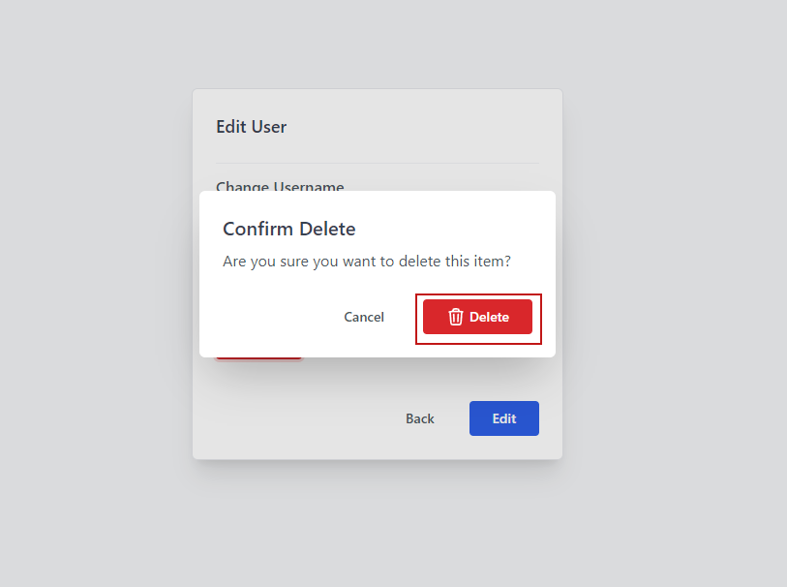

*Figure 15 – Delete confirmation popup*

#### Viewing Events

The event view provides access to the event data. The events are displayed in a paginated table. *(see Figure 16)*

*Figure 16 – Admin portal events view*

Each row in the table can be clicked to view more details and options. *(see Figure 17)*

*Figure 17 – Admin portal event details view*

By clicking the vertical ellipsis icon in the right-hand panel, the event can be deleted or edited.

#### Viewing Locations

Similar to the events view, the location view provides the ability to view and manage the locations in which events are held. *(see Figure 18)*

*Figure 18 – Admin portal locations view*

Just like in the events view, each location can be clicked on to see more information and options. *(see Figure 19)*

*Figure 19 – Admin portal location details view*

Clicking on the vertical ellipsis icon in the side panel will provide options for deleting and updating the location.

#### Viewing Drawings

The drawing view contains all of the drawings that have been drawn and uploaded using the Android drawing application during events. *(see Figure 20)*

*Figure 20 – Admin portal drawings view*

Just like in the previous views, clicking on each record opens the side panel where more detail about the drawing can be found. *(see Figure 21)*

*Figure 21 – Admin portal drawing details view*

Clicking on the vertical ellipsis icon in the side panel provides options for editing and deleting the drawing.

#### Scoring Drawings

The scoring view provides an interface for scoring the drawings. The drawing is displayed on the left side and a list of topics is displayed on the right side. To score the drawing the scorer must select the topics they wish to score and then press next or submit score if no topics are selected, therefore, giving the drawing a breadth score of 0. *(see Figure 22)*

*Figure 22 – Admin portal scoring view*

For every selected topic the scorer must then rate the extent and depth of the drawing, and optionally add a note for each score. *(see Figure 23)*

*Figure 23 – Admin portal scoring view, topic score selection*

On the last selected topic, the “Next” button will change to a “Submit Score” button and upon pressing it the score will be saved to the database and the scorer will be navigated back to the drawings.

# Security

To keep both the data and the drawing and admin portal applications secure, do not publicly share any of the secret keys, the application installers or the source code.

If any of the secret keys leak, a developer will be required to change them.

# Maintenance & Updates

Team M will provide support with critical issues & updates for three months after the handover *(10th of May 2023).* However, additional functionality and other updates will have to be facilitated by you.

# Support & Contact Information

For any questions or technical support, you can contact any of the four members of team M.

* Kieran Jeffery - [kieran.jeffery@students.plymouth.ac.uk](mailto:kieran.jeffery@students.plymouth.ac.uk)
* Oliver Barty - [oliver.barty@students.plymouth.ac.uk](mailto:oliver.barty@students.plymouth.ac.uk)
* Emma Freeman - [emma.freeman@students.plymouth.ac.uk](mailto:emma.freeman@students.plymouth.ac.uk)
* Justas Galminas - [justas.galminas@students.plymouth.ac.uk](mailto:justas.galminas@students.plymouth.ac.uk)

# Developer Guide

This developer guide aims to provide some basic information about the hosting and configuration of the project. For additional information and documentation see the GitHub repository.

## Repository

<https://github.com/Plymouth-University/comp2003_2022-team-m>

## Hosting

Docker images/containers have been configured for the API and the database, therefore, those can easily be hosted on a platform of your choosing, providing it supports Docker.

*Note: After hosting the API, make sure to change the current API URL in both client applications — the Android drawing app and the admin portal.*

## Configuring Backblaze

The drawings produced during events are stored using a third-party cloud provider — Backblaze. To configure Backblaze within the API you will need to create a Backblaze account and provide your own API and bucket keys.

### Instructions

1. Sign up.
2. Navigate to “My Account” page.
3. Navigate to “App Keys” section.
4. Click on the “Add a New Application Key” button and create a new key.
5. You will then be shown the Key ID and the Application Key. *(see Figure 24)*

*Figure 24 – Popup after API key creation in Backblaze account settings*

1. Copy the “keyID” and “applicationKey” values from the success dialog and paste them into the appsettings.json file in the API. *(see Figure 25)*

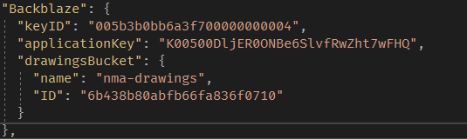

*Figure 25 – appsettings.json Backblaze section*

1. Then while still in account settings, head to “Buckets”.
2. Click “Create a Bucket”.
3. Once created, copy the bucket name and the “bucket ID” values and paste them into the appsettings.json file under the “drawingsBucket” property. (see Figure 25)
4. Build the application.
5. All done, the API should be able to communicate with your Bacbklaze service now and read and write drawing files.